[PSoC 4 Pioneer Kit Community Project#18 - 'Catch the Shells' Game with ColorLCD Shield](http://www.element14.com/community/message/77648#77648/l/psoc-4-pioneer-kit-community-project18--catch-the-shells-game-with-colorlcd-shield)

Today's project posting implements another simple and fun game using the PSoC 4 Pioneer Kit + the ColorLCD Shield.

 The goal of the game is to catch as many shells as possible. The shells are dispatched from one edge of the Color LCD and the user has to catch these shells by moving a yellow bar using the CapSense slider. The no. of caught shells and missed shells are displayed at the bottom of the Color LCD.

[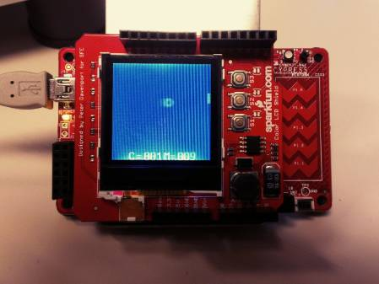](http://www.element14.com/community/servlet/JiveServlet/showImage/2-77648-149784/project18.JPG)

 The interesting thing about this project is the use of the a ColorLCD as output (over SPI), and the CapSense Slider as the inputs. The project also implements a Counter to help with designing the game algorithm. With all of the Input and Output handled in hardware (Serial Comm. Block for SPI, TCPWM Block for Counter), the CPU is free to implement the smarts of the game.

[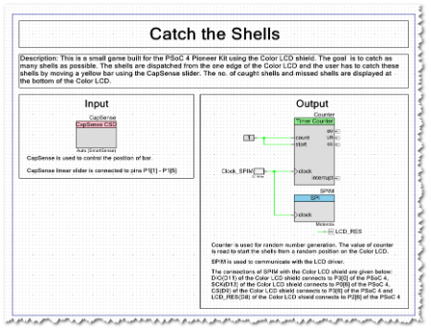](http://www.element14.com/community/servlet/JiveServlet/showImage/2-77648-149777/project18_schematic.png)  [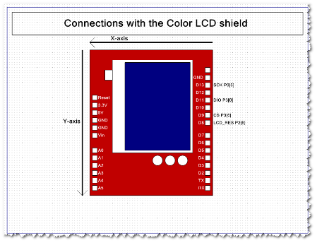](http://www.element14.com/community/servlet/JiveServlet/showImage/2-77648-149778/project18_schematic2.png)

 Hardware connections:

No extra connections required besides plugging in the ColorLCD shield.

See screenshot below for the pin mapping done in the PSoC Creator project.

[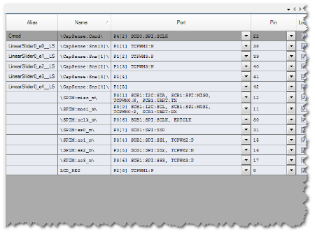](http://www.element14.com/community/servlet/JiveServlet/showImage/2-77648-149779/project18_gpio.png)

 So, what's your highest score? My fat fingers only managed a high score of 33, i'm pretty sure you can beat me!

 Your assignment - try to adjust the CapSense slider sensitivity to make the game "easier" or "harder" to play! This could be a fun experiement to run on your board.

<http://www.element14.com/community/message/77648>